Abnormal Detection for Home Activity based on Sequence Pattern

Abstract—In Malaysia, the old-age population continues to grow. At the same time, young adults are unable to take care of their elderly parents due to work commitment. This results in increasing number of elderly living in solitude. Abnormal behavior in carrying out home activities may be related to health condition of elderly. Therefore, it is crucial to monitor elderly’s behavior especially pattern of daily home activities. Past works proposed the use of complex machine learning algorithms to detect anomalies in daily sequences of home activities. In this paper, a simple and alternative anomaly detection method for detecting anomalies in pattern of daily sequences of home activities is presented. The experiment results demonstrated that the model achieved a test accuracy of 90.79% on a public dataset.
Keywords—elderly, anomaly detection, sequence pattern, home activities

Introduction
According to World Health Organization, the population of elderly (60 years old and over) in the South East Asia region has a likelihood of increasing to around 12% in 2025 [1]. In Malaysia, the Department of Statistics estimated an increase in old-age population (65 years and over) from 2 million to 2.1 million [2]. Due to work commitment, young adults are unable to look after their elderly parents all the time. A solution to this problem is to hire a caretaker to look after the elderly. This solution has several limitations. Firstly, caretaker service might not be affordable for some family due to its expensive price. Secondly, it is difficult to hire caregivers to take care of the elderly parents for 24/7. Amid the development of Internet of Things (IoT) technology and machine learning, an alternative solution known as activity recognition arises. By installing sensors at home and applying machine learning algorithm to classify sensor data, the activities of a person at home can be tracked and recorded [3][4]. In a retirement town, activity recognition can be used to monitor a large number of elderly residents with a few human experts.
Behavioral changes in carrying out home activities may be related to elderly’s health decline. For example, sudden increase in sleeping duration during day time may imply that elderly is not well. With activity recognition, the historical records of elderly’s home activities can be obtained. By conducting data analysis on these records using anomaly detection method, changes in behavior of elderly can be detected. In this paper, an anomaly detection method to detects anomalies in pattern of daily sequences of home activities is presented. Fig 1 illustrates an example of sequence of home activities which consists of all the activities happened in a day from 0:00 to 23:59. Each daily sequence is a piece of data instance in this paper.
In Section II, the related work on home activity anomaly detection is presented. In Section III, the methodology of the anomaly detection method is given. In Section IV, we discuss about the results of the experiment. Finally, conclusion and future work are given in Section V.
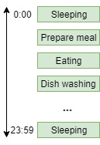
- An example of daily sequence of home activities

Related Work
In this section, literature review on related work are presented. The anomaly detection methods used include Hidden Markov Model (HMM), Recurrent Neural Network (RNN), PrefixSpan, rule-based method and Markov chains.
In [5], Forkan and colleagues proposed an anomaly detection based on HMM to detect anomalies in terms of sequence pattern of home activities. For HMM, the number of hidden states is an unknown parameter. They trained several models with varying number of states on a synthetic dataset generated based on public datasets. The results showed the method has an accuracy of 90% averagely.
Arifoglu and Bouchachia [6] presented an anomaly detection method using Recurrent Neural Network (RNN) to detect abnormal behavior for elderly with dementia with a true positive rate of 91.43% and a false positive rate of 40.96%. In this work, daily activity sequences of a public dataset were used as normal data. Whereas, abnormal data were artificially generated by injecting some abnormal activity sequence into the normal data. They trained the RNN on a training set of activity sequences. For each activity sequence, the recurrent neural network outputted a confidence value which ranges from 0 to 1. The average of confidence values of the training set was used as threshold for anomaly detection. Given an activity sequence and a trained RNN model, if its confidence value outputted by RNN is higher than a threshold, then it is classified as normal and vice versa.
In [7], Hoque and colleagues used PrefixSpan and statistical method for anomaly detection. First, they retrieved home activity sequence that are frequent in a dataset with a sequential pattern mining algorithm called PrefixSpan. Then, they modeled the duration and interval between activities with Gaussian distribution for anomaly detection.
On the other hand, Riboni and partners [8] introduced a rule-based anomaly detection method to detect anomalies in home activity of patients with mild cognitive impairment. They defined sequences of activity that are unique to dementia patients.
Zhao and colleagues [9] introduced a method using 2 Markov chains to detect anomalies on an elderly’s location sequences at home with a high detection ratio of 92.539%. For this method, a Markov chain was trained on normal data whereas another was trained on abnormal data. Given an unseen location sequence, a ratio of probabilities calculated given these trained Markov chains is used to classify whether it is anomalous or not.
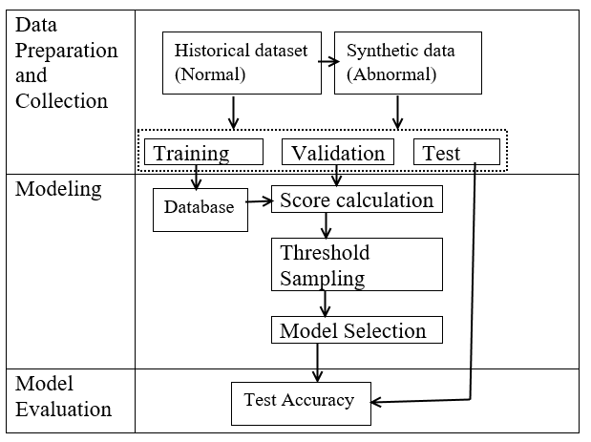
- Flow of Methodology

Methodology
Fig. 2 illustrates the flow of methodology to build the anomaly detection model to detect anomalies on daily sequence of home activities. The following subsections explains the flow of methodology which include (A) data collection, (B) data preparation, (C) modeling and (D) model evaluation.

Data Collection
The dataset [10] used in this research is the “Aruba” dataset downloaded from website of CASAS, Washington State University. It is a daily life record of an adult volunteer for 220 days living in a smart home installed with multiple kinds of sensors such as motion sensor for activity recognition research.
The dataset consists of the volunteer’s daily home activities and their respective timestamp and sensor state. Table I displays all 11 types of activity that appear in the dataset and their corresponding number of occurrences.
The daily sequences of home activities in the dataset were used as normal data in this research. On the other hand, abnormal data were generated by randomly inserting multiple toileting and sleeping activities at night time of normal daily sequence of home activities. This simulates abnormal activities of a diabetes symptom called nocturia which is an event of waking up many times during sleep time to urinate.

- Types of Activities and Number of Occurences
Type of activity | Number of occurrences
Prepare meal | 1606
Relax | 2910
Eating | 257
Work | 171
Sleeping | 401
Dish washing | 65
Toileting | 157
Enter home | 431
Leave home | 431
Housekeeping | 33
Respirate | 6

Data Preparation
In this subsection, the way to transform the dataset into model’s desired format is detailed. It consists of 3 steps which are data cleaning, data processing and data partitioning.
Data cleaning aims to remove noise in the dataset. There are 3 types of noise in this dataset. The first type of noise is occurrence of activity sandwich. Activity sandwich is a unique characteristic of Aruba dataset where some of the activities happened (sandwiched) in between beginning and end of another activity. This type of data needed to be removed because they may affect model’s performance. The second type of noise is that some daily sequences of home activities has length that varied too much from the length of the rest of the sequences. Fig. 3 shows a histogram that indicates the lengths of home activity sequences. Obviously, some daily sequences of home activities have length that varied too much from the rest. During noise removal process, any sequences with length less than 10 or more than 30 were removed. The third type of noise is existence of rare activities. As shown in Table I, “Respirate” only occurred 6 times in the entire dataset. Therefore, it was removed from the dataset. The size of remaining data is 189.
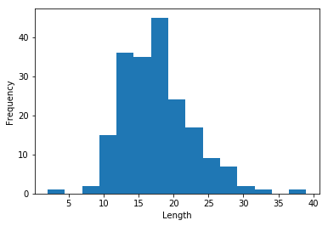
- Histogram of home activity sequence length for Aruba dataset
The second step of data preparation is data processing. Data processing converts the dataset into desired format required by the anomaly detection model. In this step, each daily sequence of activity was segmented into shorter sequences by applying a sliding window of size 3 and step size of 1. Thus, each segmented sequence consists of 3 activities. For example, given a daily sequence of activities of length 5 (Sleeping, Prepare meal, Eating, Dish washing, Relax), we can split it into 3 segmented sequences which include (Sleeping, Prepare meal, Eating), (Prepare meal, Eating, Dish washing) and (Eating, Dish washing, Relax).
- Data Partitioning
 | Small | Medium | Large
Training | 30 | 60 | 113
Validation | 76 | 76 | 76
Test | 76 | 76 | 76

The final step of data preparation is data partitioning. During data partitioning, data instances were split into training, validation and test set. To investigate the effects of training set size on the performance of the anomaly detection method, 3 different training set sizes were used and labelled as small, medium and large as listed in Table II. The training set consists of only normal data instances split from 189 normal data instances. The size of validation and test set are 76 respectively (each consists of 38 normal data instances and 38 abnormal data instances) regardless of the training set size.
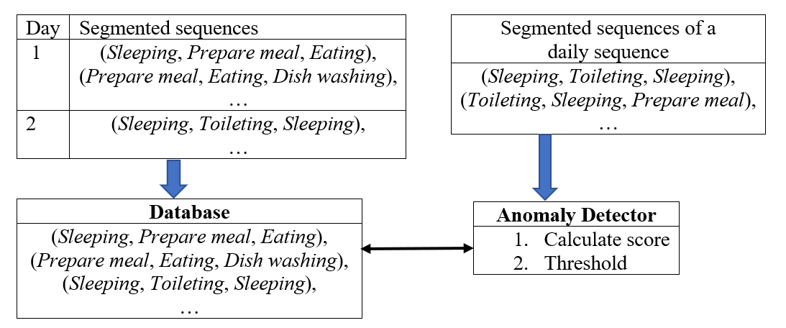
- Overview of the anomaly detection model

Modeling
An anomaly detection method works by first training a model using normal data instances. Given a new data instance, the trained model takes it in as input and a score can be calculated. Then, we compare this score with the threshold to classify the data instance as anomalous or not.
Fig. 4 illustrates the components of the anomaly detection model which include database and anomaly detector. The following subsections include model description and training process, threshold sampling and model selection.

Model description and training process: The first component of the proposed model is the database. The database models a subject’s sequence pattern of home activities. During the training process, the segmented sequences of the training set were saved into the database. For this method, each unique segmented sequence is only saved once. In the experiment, 3 different databases were trained using 3 training set with varying size.
The second component is the anomaly detector. Basically, the anomaly detector decides whether a new data instance (daily sequence of home activities) is anomalous or not. Given a data instance, the first step is to split the data instance into segmented sequences by applying a sliding window of size 3 and step size 1 as described in Data processing step. Then, we check whether each of the segmented sequences is recorded in the database or not. A segmented sequence of a data instance which is not saved in the database is called an abnormal segmented sequence. After checking all segmented sequences, a score can be calculated for that data instance using (1). The score is actually the percentage of abnormal segmented sequence out of all segmented sequences of the given data instance. Threshold is a parameter of the model which is used to classify data instance as normal or abnormal. If the score is higher than the threshold, then the data instance is classified as anomalous and vice versa.
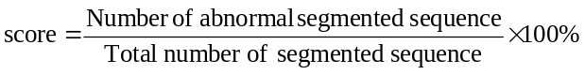 

Threshold Sampling: In anomaly detection task, threshold is the cutting point which decides whether a new data instance is anomalous or not. Threshold is a unknown parameter of the model. This means that the optimal choice of threshold is not known. Therefore, we have to systematically sample some threshold choices, evaluate them and choose the best one. After the process of training, a score was computed for each of the 76 data instances in the validation set. The minimum and maximum of the 76 scores were taken as the minimum and maximum of the range of possible threshold. In the experiment, 10 threshold choices were linearly sampled from this range for each category of training set size. Up to this point, we have 30 models with different database and varying threshold.

Model Selection: The model selection is a process to select the best model out of all existing models. For this purpose, an evaluation metric called F1 score is used to quantify the performance of each model.
- Confusion Matrix
 |  | Predicted
 |  | Positive | Negative
Actual | Positive | True positive, TP | False negative, FN
Actual | Negative | False positive, FP | True negative, TN

The F1 score can be derived from Confusion Matrix shown in Table III. In anomaly detection task, positive refers to abnormal whereas negative refers to normal. True positive and True negative are correctly classified data instances. On the other hand, False positive and False negative are misclassified data instances.
From Confusion Matrix, we can derive two metrics which are precision and recall as shown in (2) and (3).
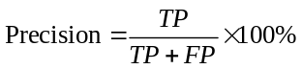 (2)
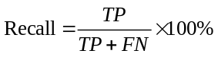 (3)
Then F1 score (as shown in (4)) can be calculated using precision and recall where F1 score is an indicator for balanced measure based on precision and recall. The F1 score for each of the models is calculated and the model with the highest F1 score is selected as best model.
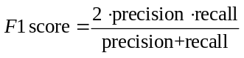 (4)

Model Evaluation
Model evaluation evaluates the performance of the selected model on an unseen test set using the performance metric, accuracy. Accuracy measures the number of correctly classified data instances over the total number of data instances. The accuracy can be computed using (5).
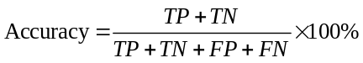 (5)

Results And Discussion
In this section, the results of the experiment are discussed. Part A shows the scores calculated for normal and abnormal data instances. Part B discusses the effects of training set size on the performance of the model. Part C discusses about the overall best model.

Normal and Abnormal Scores
Fig. 5 visualizes the scores calculated for the data instances in the validation set. Visually, the normal scores and abnormal scores generally formed two clusters, with some outliers. Majority of normal scores are 0% whereas the abnormal scores clustered around 5%.
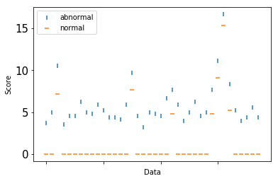
- Scores of the data instances in the validation set

Effects of Training Set Size
In this experiment, 3 different training set sizes including 30, 60 and 113 were used. Data size of 30 and 60 corresponds to 1 month and 2 months of data respectively. Compared to a machine learning dataset, the largest training set size which is 113 is relatively small. This is due to the model takes in activity sequence for a whole day as a single piece of data instance. Therefore, collecting large dataset for this problem would takes a very long time. The training set size of 113 which is almost 4 months of data is reasonably large.
Ten threshold choices were sampled for each category of training set size. This results in 30 models with varying database and threshold. In Table IV, the F1 score of the best model for each category of the training set size is listed. The results in Table IV shows performance of the model improves with increases in training set size.
- F1 Score of the Best ModelS For Each training set
Training set size | F1 score
30 | 79.17%
60 | 82.61%
113 | 88.37%

Overall Best Model
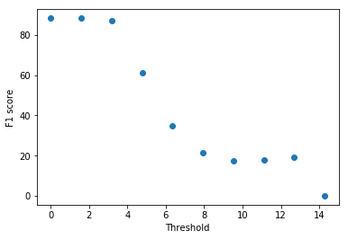
- F1 scores of 10 models with varying threshold
Fig. 6 shows the F1 score calculated for each of the 10 models with varying threshold choice for the training set size of 113. The plot shows that the F1 score decreases as threshold increases. The model with threshold 0% has the highest F1 score of 88.37% and was selected as the best model.
Table V lists the performance metrics of the selected model. The model has a high test accuracy of 90.79% with a 3.95% difference from the validation accuracy. It shows the performance of the model can generalize well to unseen testing data.
- Performance Metrics Of Overall Best Model
 | Validation | Test
Precision | 79.17% | 84.44%
Recall | 100% | 100%
Accuracy | 86.84% | 90.79%
F1 score | 88.37% | 91.57%

Conclusion And Future Work
In this paper, an anomaly detection method in detecting a person’s anomaly based on his/her usual daily home activities pattern is presented. The experiment was carried out using public dataset and the results demonstrated the method has a good performance in terms of precision, recall and accuracy. However, there are a few investigations can be carried out in future, which include:
- The size of sliding window. Current sliding window size is set as 3 but further investigation on the efficiency of sliding window size can be studied.
- The current performance of method is dependent on training set size. Hopefully, the method can be enhanced further in future to reduce the reliance of the anomaly detection method on training set size.

References

- World Health Organization, “Health situation and trend assessment,” 2018. [Online]. Available at: http://www.searo.who.int/entity/health_situation_trends/data/chi/elderly-population/en/
- M. U. Mahidin, “Selected demographic indicators,” Department of Statistics Malaysia, August 2018.
- O. D. Lara and M. A. Labrador, “A survey on human activity recognition using wearable sensors,” IEEE Communications Surveys and Tutorials, vol. 15, no. 3, pp. 1192-1209, 2013.
- A. Bux, P. Angelov and Z. Habib, “Vision based human activity recognition: a review”, Advances in Computational Intelligence Systems. Advances in Intelligent Systems and Computing, vol. 513, pp. 341-371, 2016.
- A. Forkan, I. Khalil, Z. Tari, S. Foufou, and A. Bouras, “ A context-aware approach for long-term behavioural change detection and abnormality prediction in ambient assisted living, “Pattern Recognition, vol. 48, Issue 3, 2015, pp. 628-641.
- D. Arifoglu, and A. Bouchachia, “Activity recognition and abnormal behaviour detection with recurrent neural networks,” Procedia Computer Science, vol. 110,2017,pp. 86-93.
- E. Hoque, R. F. Dickerson, S. M. Preum, M. Hanson, A. Barth and J. A. Stankovic, "Holmes: A comprehensive anomaly detection system for daily in-home activities," 2015 International Conference on Distributed Computing in Sensor Systems, Fortaleza, 2015, pp. 40-51.
- D. Riboni, C. Bettini, G. Civitarese, Z. H. Janjua, and R. Helaoui, “SmartFABER: Recognizing fine-grained abnormal behaviors for early detection of mild cognitive impairment,” Artificial Intelligence in Medicine, vol. 67, pp. 57-64, 2016.
- Zhao T., Ni H., Zhou X., Qiang L., Zhang D., Yu Z, “Detecting abnormal patterns of daily activities for the elderly living alone,” in Zhang Y., Yao G., He J., Wang L., Smalheiser N.R., Yin X. (eds) Health Information Science. HIS 2014. Lecture Notes in Computer Science, vol 8423. Springer, Cham.
- D. Cook, Aruba, Center for Advanced Studies in Adaptive Systems, Washington State University, 2011. [Online]. Available at: http://casas.wsu.edu/datasets

